Tower A: Physics-Informed Field Encoder
Rationale and modeling assumptions
Our goal in Tower A is to transform a multichannel microstimulation (TDT-RZ2) command into a electric-field representation around the implanted VPL array, one that downstream learning (Tower B) can use to predict S1 responses. Because intracortical pulses are short and tissue behaves (to first order) as a resistive medium over these timescales, we adopt the quasi-static conduction model: the potential $ϕ(x)$satisfies the divergence form of Laplace’s equation in an ohmic medium, and the electric field is $E(x)=-∇ϕ$, $J(x)=σ(x) E(x)$. PINNs are a accepted fit for this setting: they let us enforce the PDE and boundary conditions while flexibly capturing geometric detail around microelectrode tips (Zeng et al. — “Physics informed neural networks for electric field distribution characteristics analysis”).
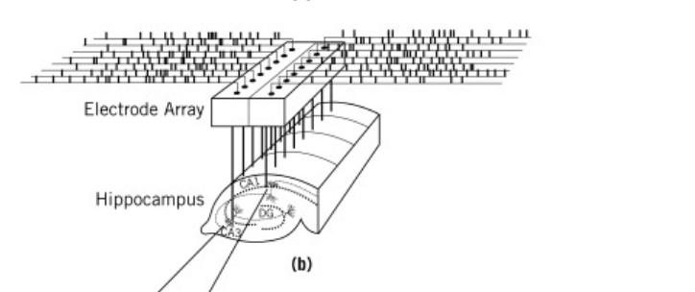
Thalamus
Crucially, the PDE is linear in $ϕ$for fixed conductivity $σ$, so fields produced by multi-electrode patterns obey superposition: the solution for any current distribution is a linear combination of unit-current basis fields (Dmochowski et al., “Optimized multi-electrode stimulation increases focality and intensity at target,”). In neuroprosthetic, this superposition motivates current steering and “virtual electrodes”—changing the current ratio between neighboring contacts translates the field maximum along the line segment between them. (Dumm et al “Virtual Electrodes by Current Steering in Retinal Prostheses”) We explicitly leverage this in both the model architecture and our sanity tests.

Conceptual Foundations: How a PINN Represents Geometry and Field Behavior
Numerical solvers such as the finite-element method (FEM) explicitly discretize space: the tissue domain is divided into a mesh of small elements, and the governing equation is solved at each node under fixed boundary conditions. Geometry and connectivity are therefore hard coded into the mesh structure itself.
In contrast, a physics-informed neural network does not rely on an explicit mesh. The network learns a continuous function. In the case of
$$ϕ_{θ}:(x,y,z)↦\text{potential }ϕ$$
that directly maps any spatial coordinate to a predicted field value. Geometry and physics are introduced implicitly through the loss function rather than a mesh:
- Interior physics: Points sampled inside the domain are used to minimize the PDE residual $∇⋅\left(σ ( x ) ∇ ϕ ( x )\right)=0 \text{in }Ω_{\text{VPL}}$. (Enforces the same physical laws by penalizing violations rather than assembling a matrix.)
- Boundary geometry: Surfaces such as electrodes, insulation, and the outer enclosure are represented using the point collocation method. Points lying on those surfaces carry their own boundary condition in the loss. The network learns to satisfy these constraints without an explicit surface mesh.
- Continuity and differentiability: Because the neural network is smooth and differentiable by design, gradients like $E=-∇ϕ$and $J=σE$can be obtained analytically by automatic differentiation, providing direct access to electric-field quantities everywhere in space.
This mesh-free representation allows the model to evaluate the potential or electric field at any arbitrary coordinate within the domain, not just at predefined nodes. Additionally, it makes physics itself responsible for shaping geometry. In summary PINN learns the geometry through physics it must satisfy.
Superposition and Corrector Design
Because the quasi-static conduction equation is linear for any fixed conductivity, both the potential field and its boundary flux scale linearly with current. The boundary condition for current-controlled stimulation is linear:
$$\int_{Γ_{j}}{σ∇ϕ⋅n dS}=I_{j}$$
That means if electrode A driven with 1 µA produces potential ϕₐ(x) and electrode B produces ϕ_b(x), then any combination of currents yields
$$ϕ\left(x;I\right)=I_{A} ϕ_{A}\left(x\right)+I_{B} ϕ_{B}\left(x\right)+…$$
Therefore, the field for any stimulation pattern can be expressed as a weighted sum of basis fields, one per electrode.
Although it’s possible to train a single large PINN that accepts all electrode currents as inputs and learns to predict the resulting field, such a model would need to learn superposition implicitly. This adds redundant complexity, so we opted to factorize the problem, rather than treating the entire array as one nonlinear system, it decomposes the forward model into a set of independent subproblems, where Tower-A trains a small PINN for each stimulating contact learning its unit current basis field. Formally, each subnetwork solves:
$${\text{PINN}}_{e}: x↦ϕ_{e}\left(x\right) \text{s.t.}∇ ⋅(σ∇ϕ_{e})=0,$$
subject to the following boundary conditions:
- flux = 1 µA on electrode e,
- zero flux elsewhere,
- and ϕ = 0 at the outer (ground) boundary.
Each learned field ϕₑ(x) then serves as a Green’s-function response, describing how current from that single electrode spreads through the tissue. Once trained, Tower-A no longer needs to solve the PDE again, these unit-current solutions are later combined linearly to reconstruct the field for any multi-electrode stimulation pattern.
Runtime field reconstruction
For any stimulation vector
$$I=[I_{1},I_{2},…,I_{M}],$$
the total potential field is reconstructed as
$$ϕ\left(x;I\right)=\sum_{e=1}^{M}{I_{e} ϕ_{e}\left(x\right)},$$
$$E\left(x;I\right)=-∇ϕ\left(x;I\right),$$
$$J=σ E.$$
This setup keeps the physics linear and lets us quickly rebuild the electric field for any electrode pattern using a weighted sum of pre-computed unit fields. A small correction can be added to fix small errors from tissue differences or boundary effects. Together, these are intended to make Tower-A fast and physically consistent

( this is equivalent in principle to field aware model Dr Francis)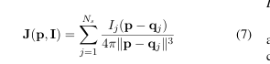

Data and stimulus parameterization (Tower A)
Each TDT block contains continuous streams and event markers. For Tower A we use: sSig/sOut (16 × 24.4 kHz; command/output waveforms) to reconstruct the delivered biphasic pulses per contact and IZn1 (16 × 1.0 kHz; measured current) as a verification channel. Event stream PC1_ (primary TTL) defines trial onsets; Wav1 (32 × 610.35 Hz; LFP) is not consumed by Tower A but is used downstream in Tower B. (Sampling choices for LFP: ~5–200 Hz band-pass and ~610 Hz sampling.) For each epoch, we compute a signed amplitude vector $I∈R^{N_{e}}$(one scalar per contact) from sOut (primary) and verify phase symmetry/charge balance against IZn1. Only the instantaneous amplitude matters for the quasi-static field.
Inputs
The model requires three classes of inputs: spatial–geometric descriptors, tissue conductivity parameters, and—when a residual correction network is used—stimulation currents.
Domain geometry and sampling:
First the spatial coordinates and geometry descriptors define the three-dimensional domain $Ω$over which the potential field $ϕ(x)$is evaluated. The coordinate frame is expressed in millimeters around the implanted VPL microelectrode array and spans a padded region of interest large enough to include all active contacts and sufficient surrounding tissue for the field to decay smoothly. Each electrode contact is modeled as a small conductive disk located at its known position within the array, while the insulated shank and encapsulating material are represented as non-conductive surfaces that enforce zero-flux (Neumann) boundary conditions. These geometric parameters—contact spacing and shank layout—are reconstructed from experimental metadata and impedance measurements. The outer boundary of the domain is modeled as a distant enclosure, like a cube or sphere 8–12 mm across, and assigned either a grounded Dirichlet potential ($ϕ=0$) or an insulating Neumann boundary, whichever minimizes edge artifacts within the region of interest. Together, these definitions establish the physical and boundary geometry in which the quasi-static conduction problem is solved.
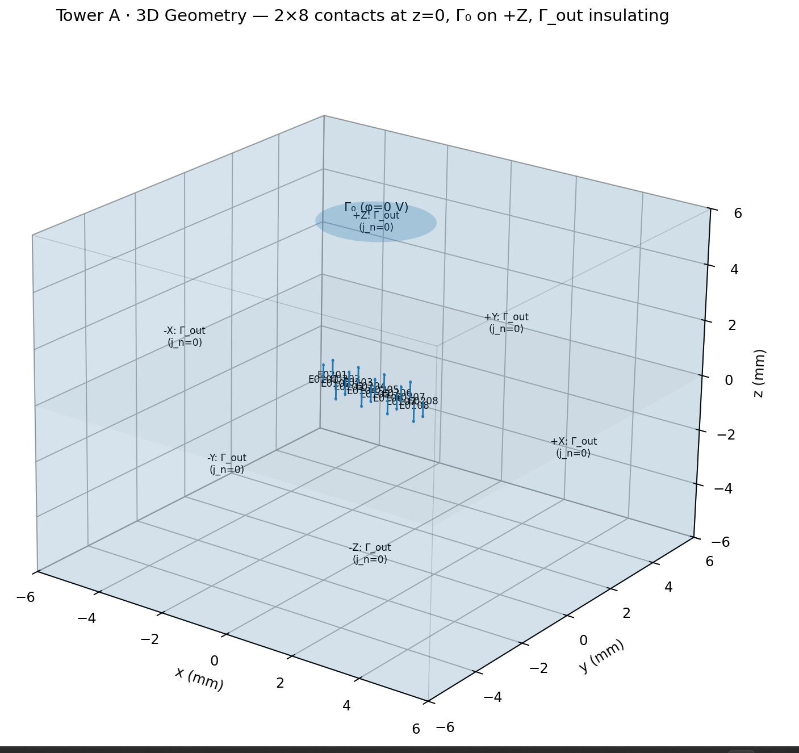
Because a neural network represents the potential V(x) as a continuous function but has no explicit mesh or surface geometry, it can’t integrate exactly over the curved electrode area. To approximate this, we use collocation sampling: many discrete points are placed on each electrode surface Γₖ, each with a known outward normal and a small surface-area weight wᵢ. The network predicts the local flux ( −σ∇V·n ) at those points, and the weighted sum of these values approximates the total boundary current. This lets the PINN numerically enforce the Neumann boundary condition and ensure charge conservation, even without an explicit geometric mesh. Within the interior, points are importance-sampled to emphasize regions near the electrode tips where field gradients are steep. Because the electric potential decays rapidly close to the metal surface and more gradually farther away, a multi-shell sampling strategy is used to capture this change across scales. Points are drawn on a series of log-spaced spherical shells centered on each electrode tip, typically ranging from 10–20 µm up to 1–2 mm. The logarithmic spacing provides dense coverage of the near-field (where |E| changes sharply) and progressively sparser sampling in the far-field (where variations are smoother). This ensures that the PINN accurately resolves the steep local gradients without wasting samples in regions where the field varies slowly. A light uniform background distribution supplements these shells to maintain coverage of the bulk tissue. During training, the sampling distribution intentionally over-represents the near-field region, since errors there have the greatest impact on downstream field-based features such as $∥E∥$, which govern neural activation thresholds. Adaptive re-weighting based on the local PDE residual can further refine this balance, effectively implementing a self-adaptive PINN that allocates more weight where the model’s physics loss is largest. This approach yields accurate field reconstructions near metal–tissue interfaces while maintaining stable generalization across the full domain.
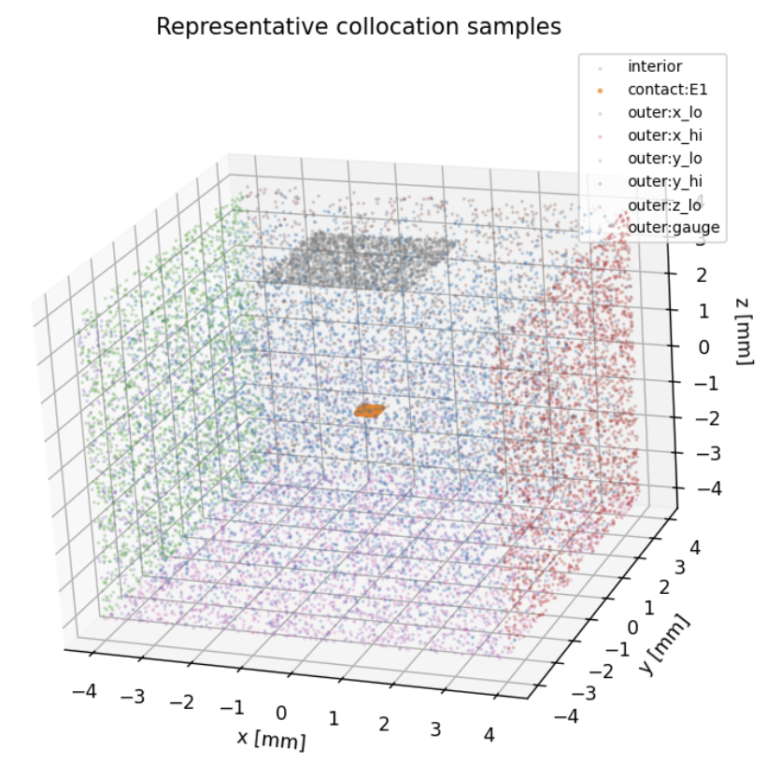
Figure 1single electrode test (Random sampling for now )

Second, the tissue conductivity parameters govern the spread of the potential field. Under the quasi-static approximation relevant to microstimulation, neural tissue behaves only as a resistive medium. The model thus begins with a homogeneous, isotropic conductivity $σ$, (in the range of 0.2–0.5 S/m for gray matter). This assumption aligns with literature values. Finally, the stimulation current vector $I$defines the current delivered through each electrode contact during a given stimulation pattern. Each component $I_{e}$represents the current amplitude (in microamperes) applied to contact $e$, with the constraint that the total injected charge is balanced across the array. In the present dataset, these current patterns are recorded alongside neural responses in the TDT epoc structures and can be reconstructed per trial from stimulation metadata. When the network includes a residual corrector term $δϕ(I,x)$, the current vector serves as a conditioning variable that allows the model to capture subtle nonlinearities in how multi-electrode current steering shapes the resulting potential distribution.
In combination, these inputs define the full forward problem for Tower-A: the geometry establishes the domain, the conductivity specifies its material properties, and the current pattern provides the boundary fluxes that drive the potential field. Together, they form a physically interpretable and data-grounded input space for training physics-informed networks that approximate electric field solutions around the implanted array.
Outputs
The model produces a set of outputs that describe the spatial distribution of electrical quantities within the defined domain. The primary output is the scalar potential field $ϕ(x,y,z)$, representing the steady-state voltage throughout the conductive tissue volume surrounding the implanted VPL array. This potential field satisfies the Laplace equation $∇⋅\left(σ∇ϕ\right)=0$under the boundary conditions imposed by the stimulation currents on the electrode surfaces and the insulating and grounded interfaces elsewhere. The potential field provides a complete physical description of how applied currents shape the local voltage landscape within the tissue.
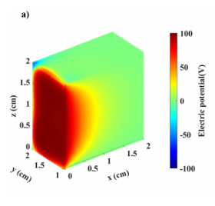
Figure 2 Example from DOI 10.1088/1361-6463/acbec3
From the potential field, the electric field is obtained as its spatial gradient $E=-∇ϕ$. The electric field characterizes the direction and intensity of current flow at each point in the domain, with strong gradients near electrode tips and diminishing values at larger distances. When combined with the conductivity tensor $σ$, the current density $J=σE$can also be derived, capturing the distribution of charge flow through the tissue. These derived observables not only serve as validation quantities against classical finite-element models but also form the basis for the data-driven coupling between the physical (Tower-A) and neural (Tower-B) components of the model.
For downstream integration, the model further extracts compact “field-aware” features from the continuous fields. The primary feature is the electric-field magnitude $∥E∥$, which summarizes local stimulation strength. In addition, direction-aware components—such as projections of $E$along anatomical or electrode-aligned axes—are computed to preserve information about field orientation, which can influence the selectivity of neural activation. These features are sampled on a fixed three-dimensional grid surrounding the array (typically 50–100 µm spacing) and cached per stimulation pattern, allowing rapid retrieval during Tower-B training and inference.
The resulting outputs provide both a full-field physical representation and a condensed set of biologically relevant features. Together, they enable Tower-A to serve as a differentiable, physics-grounded encoder that transforms stimulation currents and electrode geometry into spatially resolved electric-field representations suitable for predicting neural responses in Tower-B.
Because the governing PDE is linear in $ϕ$for any fixed conductivity $σ$, the potential field corresponding to an arbitrary current pattern $I$can be reconstructed as a linear superposition of precomputed unit-current solutions, one per electrode contact. Each basis field $V_{e}(x;I_{e}=1)$therefore serves as a reusable Green’s function describing how current from a single electrode distributes through the tissue. This superposition property allows Tower-A to generate new field configurations instantly for any stimulation pattern, while retaining full physical consistency with the underlying conduction model.

Network Architecture

Activation Function
The neural network implemented in Tower A is a feed-forward multilayer perceptron (MLP) that maps three-dimensional spatial coordinates to the scalar potential field,
$$(x,y,z) ↦ ϕ_{θ}(x,y,z),$$
The MLP represents the potential as a continuous and differentiable mapping that can be evaluated at any point within the domain. Each layer of the network performs the transformation followed by the activation:
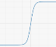
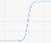
$$y(x)= σ(\sum_{i=1}^{n}{w_{i}x_{i}+b})$$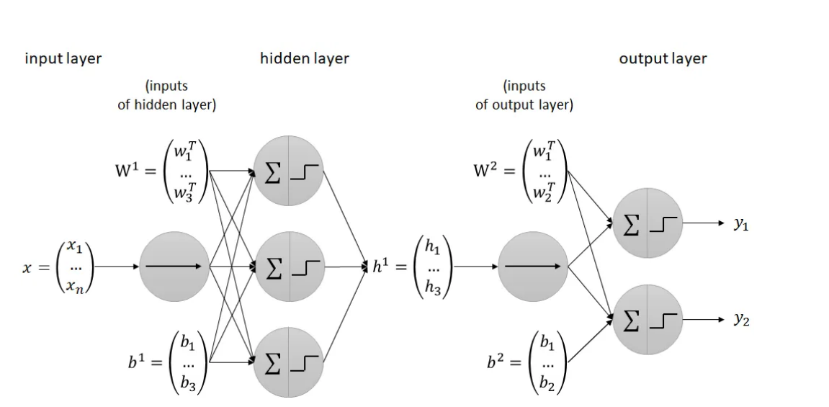
Figure 3https://www.mdpi.com/2227-7390/12/12/1920
where $W_{k}$is the learned weight matrix, $b_{k}$is the bias vector, $σ(⋅)$is the activation function, and $h_{k}$denotes the layer’s feature representation. In this work, the hyperbolic tangent (tanh) activation was selected due to its smoothness, differentiability, and ability to capture continuous gradients. However, this choice also imposes certain limitations. For the present homogeneous model, these trade-offs are acceptable, but future extensions to multi-region or anisotropic tissue models may benefit from domain-decomposed or adaptive activations (e.g., sinusoidal or piecewise linear units).

Loss Function
The total loss function is comprised of three main components:
- an interior PDE residual term that ensures the potential field satisfies the Laplace equation throughout the domain
- a set of boundary flux terms that impose the electrode currents under current-controlled stimulation
- and an insulation term that enforces zero-flux conditions on domain boundaries.
Because the Dirichlet gauge is imposed analytically through the ADF transformation, no explicit Dirichlet penalty appears in the loss.
The final objective is
$$\boxed{L_{\text{Tower A}}=λ_{\text{PDE}}L_{\text{PDE}}+λ_{\text{flux}}L_{\text{flux}}+λ_{\text{ins}}L_{\text{ins}}.}$$

Interior residual
The primary term is the PDE residual loss, which ensures the field satisfies the quasi-static conduction equation throughout the interior of the domain:
$L_{\text{PDE}}=\operatorname{MSE}\left(∇⋅\left(σ_{θ}∇ϕ_{θ \text{(p}\text{red}\text{)}}\left(x\right)\right)\right)$ (1)
This term penalizes deviations from the condition required for steady-state current flow. The inputs are each collocation point $x_{i}$sampled inside the domain. Using PyTorch’s autograd, we compute the spatial derivatives:
$$∇ϕ_{θ}(x)=[\begin{aligned}∂ϕ/∂x \\ ∂ϕ/∂y \\ ∂ϕ/∂z\end{aligned}]$$followed by the flux computation. The divergence of this flux, computed again via autograd, gives:
$$∇⋅J=\frac{∂J_{x}}{∂x}+\frac{∂J_{y}}{∂y}+\frac{∂J_{z}}{∂z}$$During training, the network parameters $θ$are iteratively updated so that the predicted potential field $ϕ_{θ}(x)$minimizes this residual across all sampled interior points.

Newman Boundary Residual (flux)
On each electrode surface $Γ_{k}$, the Neumann boundary condition prescribes the normal current density $J_{n}^{\text{target}}(x)$, representing the desired current flow from that contact into the surrounding medium. In practice, this constraint is enforced through two complementary loss components: a local area-weighted term that shapes the spatial distribution of the surface flux, and a global integral constraint that guarantees total current conservation per electrode. Together, these ensure both local physical fidelity and global charge balance.
(a) Area-weighted boundary MSE
$$\begin{matrix} & L_{\text{flux,pt},k}=\sum_{i∈Γ_{k}}{w_{i}[(-σ∇ϕ⋅n)(x_{i})-J_{n}^{\text{target}}(x_{i})]^{2}} & & \text{(2)}\end{matrix}$$
where $w_{i}$are quadrature weights chosen so that the discrete sum approximates a surface integral. This term enforces that the predicted normal flux density at each sampled surface point matches the prescribed distribution, maintaining a realistic spatial pattern of current emission across the contact face. Without this local constraint, the model could satisfy total current balance while producing an unphysical, uneven flux distribution.
(b) Integral current constraint
$$\begin{matrix} & L_{\text{flux,int},k}=(\sum_{i∈Γ_{k}}{w_{i}(-σ∇ϕ⋅n)(x_{i})-I_{k})^{ 2},} & & \text{(3)}\end{matrix}$$
which enforces that the total injected current $I_{k}$through electrode $k$equals the commanded stimulation current. This “safety-belt” term preserves overall charge balance even if minor local errors occur in the pointwise flux predictions, preventing drift in the net injected current over training.
To ensure electrodes operating at different current amplitudes contribute comparably to the total loss, each flux term is scaled by a characteristic flux magnitude
$$J_{0,k}=\frac{∣I_{k}∣}{A_{k}},$$
where $A_{k}$is the electrode’s active surface area. Flux collocation points are sampled densely on each active face while omitting a small margin near sharp edges or corners to avoid singular gradients. The outward normal vector $n$is consistently oriented to maintain sign consistency, as a flipped normal would invert the target flux direction.
The total flux loss is then the weighted sum over all stimulating electrodes:
$$\begin{matrix} & L_{\text{flux}}=\sum_{k}{(λ_{\text{pt}}L_{\text{flux,pt},k}+λ_{\text{int}}L_{\text{flux,int},k})}. & & \text{(4)}\end{matrix}$$

Newman Boundary Residual insulated surface
In addition to the active electrode faces, the Tower A geometry contains several insulating surfaces—including the shank walls, encapsulant, and inactive contact backs—that must prevent any current flow. These regions are governed by a homogeneous Neumann boundary condition, To enforce this condition, a zero-flux penalty is added to the loss function:
$$\begin{matrix} & L_{\text{ins}}=λ_{\text{ins}}\sum_{x_{i}∈Γ_{\text{ins}}}{[(-σ∇ϕ⋅n)(x_{i})]^{2}.} & & \text{(5)}\end{matrix}$$
This term prevents spurious current leakage through non-conductive boundaries, ensuring that all injected charge exits exclusively through the designated active electrodes.
Although its computational cost is minimal—it reuses the same gradient evaluations as the electrode flux loss—it is physically essential for maintaining charge conservation and field stability. A moderate weighting (typically $λ_{\text{ins}} \text{⁣}≈ \text{⁣}1$) is sufficient, and adaptive weighting can automatically balance it relative to the PDE and flux losses.

Dirichlet boundary condition :
The Laplace equation is linear but not unique, any constant offset added to ϕ still satisfies the PDE. Two issues must therefore be handled separately:
- fixing the additive gauge, since the Laplace solution is defined only up to an arbitrary constant
- enforcing Dirichlet constraints in a way that remains numerically stable and optimizer-friendly.
Thus, the objective is to obtain a solution that is unique, physically meaningful, and consistent with the Neumann-dominant architecture used in Tower A. In selecting how to enforce the Dirichlet gauge, we are avoiding the traditional penalty-based formulation, which introduces an additional loss term weighted by a constant. This approach is known to make the optimization problem ill-conditioned and highly sensitive to the relative scaling between PDE, Neumann, and Dirichlet losses. As demonstrated by Berrone et al. (2023). For these reasons, we adopted a hard-constraint strategy.
Two hard-constraint methods were evaluated for this purpose. The first, the Approximate Distance Function (ADF) method, modifies the network output using a signed or normalized distance field d(x) that vanishes exactly on the Dirichlet boundary Γ_D. The resulting transformation, ϕ̃θ(x) = g(x) + d(x) nθ(x), ensures that ϕ̃θ = g is satisfied identically on Γ_D and removes any dependence on penalty coefficients.
A more general but algebraically heavier alternative is the Theory of Functional Connections (TFC), which constructs an analytic constrained expression embedding the boundary condition directly into the trial solution. TFC enforces both Dirichlet and, in principle, Neumann constraints exactly, converting the PDE learning problem into an unconstrained one. As summarized in Recent Advances in Physics-Informed Machine Learning (2024), TFC-based constrained PINNs have been successfully applied to inverse and coupled problems, often improving convergence and interpretability when strict boundary adherence is required.
In the present Tower A architecture, however, the Dirichlet boundary acts only as a numerical gauge rather than a physical electrode held at a fixed potential. Thus, the ADF formulation provides the optimal balance between mathematical rigor, implementation simplicity, and compatibility with the existing Neumann flux losses. TFC remains a viable extension path for future work if broader analytic constraint embedding or implicit (CPIDINN-style) architectures are pursued.
Because the Dirichlet gauge in Tower A is enforced as a hard constraint rather than a penalized loss, it is integrated directly into the model output through an Approximate Distance Function (ADF) transformation. Let $d(x)$denote a signed or normalized distance field that vanishes on the Dirichlet boundary $Γ_{D}$and is positive elsewhere and let $g(x)$be the prescribed boundary value (zero on $Γ_{D}$). The neural network $n_{θ}(x)$represents the unconstrained component of the potential field.
The total predicted potential is therefore expressed as
$$\begin{matrix} & \boxed{{\tilde{ϕ}}_{θ}(x)=g(x)+d(x) n_{θ}(x)} & & \text{(1)}\end{matrix}$$
By construction, $d(x)=0$for all $x∈Γ_{D}$, so
$${\tilde{ϕ}}_{θ}(x)=g(x)\text{on}Γ_{D},$$
and the Dirichlet condition is satisfied exactly without requiring a loss term or weighting factor.The neural network learns only the free function $n_{θ}(x)$, which governs the potential variation inside the domain while automatically respecting the fixed boundary value.
For Tower A, $g(x)=0$and $d(x)$is defined as the Euclidean distance from a point in the domain to the small “gauge patch” on the outer wall of the bounding box.
For a planar patch centered at $(x_{0},y_{0},z_{0})$with half-sizes $a,b$, a simple composite form of $d(x)$is
$$\begin{matrix} & d(x)=\sqrt{max⁡(∣x-x_{0}∣-a,0)^{2}+max⁡(∣y-y_{0}∣-b,0)^{2}} +∣z-z_{0}∣. & & \text{(2)}\end{matrix}$$
This distance vanishes exactly on the gauge patch and remains positive elsewhere, ensuring smooth enforcement of the boundary condition while avoiding spurious zeros.

Training Process
Vvvvvv Next Stage will be working on above material for a while ( 10/31/25) vvvvvvvvv
Training begins with weighting parameters ( \lambda_{\text{PDE}} = 1 ), ( \lambda_{\text{flux}} = 10 ), ( \lambda_{\text{ins}} = 1 ), and ( \lambda_{D} = 50 ) (if Dirichlet is used). These are later refined automatically using self-adaptive weighting or residual-based attention, which increases the emphasis on regions where the physics residuals are highest—typically near electrode tips where gradients are steep. Optimization proceeds using Adam followed by L-BFGS, a standard two-stage PINN schedule that combines stability during early training with rapid convergence at the end.
Together, these terms ensure that each learned basis field (and any corrector) simultaneously satisfies the Laplace equation, enforces correct boundary fluxes, and maintains charge conservation across all electrodes. The result is a family of physically consistent, reusable basis solutions that form the foundation of Tower-A’s superposition framework.

EVALUATION

Outputs, feature extraction, and caching
Tower A returns (i) the continuous potential field $ϕ$, (ii) vector field $E=-∇ϕ$, and (iii) field-aware features aggregated on a fixed grid around the array—for Tower B we use primarily the magnitude $∣E∣$and, when directional effects are hypothesized, projections along anatomical or electrode-aligned axes. To interoperate with prior work and enable LOCO comparisons, we sample on a fixed 3-D grid (50–100 µm spacing with ~200 µm padding). The S1 study that introduced the field-aware sensitivity map did exactly this (∼18,800 points at 50 µm spacing) and showed that such field-aware features—coupled to a smoothness (roughness) prior on the spatial sensitivity—improve LOCO generalization relative to current-only baselines. We adopt the same representation for parity and downstream robustness.
The internal report already codifies this Tower A output contract (full field + compact field-aware features), and we follow it here without changes.

Sanity checks and ablations
We include physics and neuroprosthetics-motivated checks after training each basis:
- Superposition/linearity: $ϕ(I_{a} \text{⁣}+ \text{⁣}I_{b})=ϕ(I_{a})+ϕ(I_{b})$within numerical tolerance.
- Charge conservation: Integrated flux over all boundaries equals $\sum_{k}{}I_{k}≈0$for charge-balanced drives.
- Current-steering test (virtual electrode): For a neighboring-pair drive with ratio $R$, verify that the field peak shifts toward the higher-current contact; this is the canonical signature of steering.
- Bipolar focusing: Bipolar returns should reduce spatial extent versus distant-return (qualitatively tighter field), consistent with intracortical bipolar selectivity observations.

Why these choices are justified (and how they reflect the literature)
- Field-aware intermediate. The S1/VPL work that motivated our design explicitly measured performance gains when mapping stimulation to field-derived features on a fixed grid, and further improved LOCO generalization by imposing a roughness penalty on the downstream spatial sensitivity—evidence that the intermediate physical field is the right “language” for generalization across novel current patterns and geometries. Our Tower A produces exactly those field features.
- Superposition by construction. Microstimulation steering relies on linear field superposition; building Tower A from unit-current bases (plus an optional small corrector) makes this property exact and fast, and mirrors the “virtual electrode” intuition used in cochlear/retinal systems.
- Physics-informed training. PINNs have been successfully applied to electric-field Laplacian/Poisson problems with complex inclusions and mixed BCs. We adopt these established patterns (interior PDE residuals + boundary constraints, with optional inverse estimation later).
- Implementation parity with PINA. Every element maps to a PINA primitive (SpatialProblem + Equation/Condition, PINN solver, Trainer, optional SelfAdaptivePINN), ensuring reproducibility and maintainability.

Limitations and extensions
We begin with homogeneous isotropic $σ$.

Notes on Tower-B linkage (for completeness)
While outside Tower A, we close the loop by sampling $∣E∣$(and optional directional projections) on the fixed grid for each stimulation pattern. This mirrors the S1 analysis pipeline and is the quantity that downstream smooth sensitivity maps used to predict RMS LFP responses—a design shown to be more stable under LOCO than current-only features.

References to key design choices (inline)
- Field-aware grid features and LOCO/stability gains; 50 µm grid with ~18.8k points; roughness prior improves LOCO vs. no roughness.
- TDT LFP preprocessing norms (5–200 Hz, ~610 Hz) used in the VPL→S1 work—context for Tower B and QC.
- Quasi-static Laplacian, PINNs for electric-field problems, mixed BC handling and inverse variants.
- Current steering/virtual electrodes: field maxima shift with current ratio—used here as a sanity test and motivation for basis superposition.
- Intracortical bipolar stimulation improves selectivity and tightens spatial activation—qualitative expectation for our focusing test.
- PINA primitives/tutorials we use: Poisson-type problems, hard/soft constraints, solver/trainer, self-adaptive weighting.

Brockmeier et al. — “Neural activity shaping with DL”
Emphasize vector-additive behavior of electric fields in multipolar stimulation

